**UHO**

United Health Organization

**Integration Technical Design Document**

**covid-papi technical design**

|  |  |  |
| --- | --- | --- |
| **Project/Service Identifier:** |  | covid process API |
| **Prepared By:** | Chinna Reddy |
| **Document Version:** | Version 1.0.0 |
| **Published Date:** | 2021/08/12 |

**Revision History**

|  |  |  |  |
| --- | --- | --- | --- |
| **Version Number** | **Revision Date** | **Summary of Changes** | **Modified by** |
| 0.1 | *2021/08/12* | Initial document created | *Chinna Reddy* |
|  |  |  |  |
|  |  |  |  |
|  |  |  |  |
|  |  |  |  |

**Contributors**

| **Name** | **Title** |
| --- | --- |
| *Chinna Reddy* | *Mulesoft Technical Architect* |
|  |  |
|  |  |
|  |  |

**Distribution & Reviewers**

| **Name** | **Title** |
| --- | --- |
| *Technical Reviewer* | *TBD* |
| *QA Reviewer* | *TBD* |
| *Architecture Reviewer* | *TBD* |
| *PM* | *TBD* |

**Approvals**

|  |  |  |  |
| --- | --- | --- | --- |
| **Interface ID** | **Interface Name** | **Approval Given On** | **Approver(s)** |
| **1** | **register-covid-case** | **TBD** | **TBD** |
|  |  |  |  |
|  |  |  |  |
|  |  |  |  |
|  |  |  |  |
|  |  |  |  |
|  |  |  |  |

**Table of Contents**

1 Introduction 1

1.1 Document Overview 1

1.1.1 Intended Audience 1

1.1.2 Structure 1

1.1.1 Related Documents 1

2 Technical Architecture 2

3 Services/APIs High level Specification 3

3.1 register-covid-case : https://uho-{env}-covid-papi/v1/covid-cases 3

3.1.1 Input and Output Definitions of API 4

3.1.2 Mapping 4

3.1.3 End system details 4

3.1.4 Consumers 4

3.1.5 Technical details 5

3.1.6 Non Functional 5

3.1.7 Error Handling 5

3.1.8 Integration test cases 5

3.1.9 API Endpoint Details 6

4 API Policies, Access and Network Security - TBD 7

5 Open Issues 8

6 Appendix A – Interface details 9

# Introduction

## Document Overview

### Intended Audience

This document is intended to be used by the integration developers, Integration support team, architects, and testers who will be designing, implementing, and maintaining these middleware services. This document is not intended to be used by the API consumers; API documentation is provided on the Anypoint platform.

### Structure

This document contains an overview and depiction of all the services. Document includes detailed designs for each service, including intended API consumers, business rules, technical considerations, and result codes.

### Related Documents

The following list provides links to related documents:

|  |  |  |
| --- | --- | --- |
| Document | Intended Use | Share point Link |
| Solution Architecture Document |  |  |
| Data Mapping document |  |  |

# Technical Architecture

1. Process API or experience API calls uhub-sapi get-covid-case-by-national-id service to check covid case exist already.
2. If case doesn’t exist then process API calls register-covid-case to add case database.
3. If the case already exist then calls update-covid-case to update the case.
4. The process API or experience API calls get-covid-reports service to get covid report by state or for all states.

# Services/APIs High level Specification

## register-covid-case : https://uho-{env}-covid-papi/v1/cases

1. This is a POST based API allows COVID case JSON payload as input then calls uhub-sapi get case by identity number to check the case already exist.
2. If already exist and the latest case record based on recent update date is of status as invalid or recovered or vaccinated again after 30 days then continuous to call uhub-sapi register case service to register as new case otherwise process continuous to call uhub-sapi update case service to update the case based identity number and goes to step 5.
3. If the case doesn’t exist then calls uhub-sapi register case service to register new case.
4. Then the process calls the aws-sapi document service to upload identity document to amazon S3.
5. Then the process calls who-sapi report service to report case to WHO.
6. API responds back 201, CREATED. On failure the API will respond back corresponding error code and message along with description.

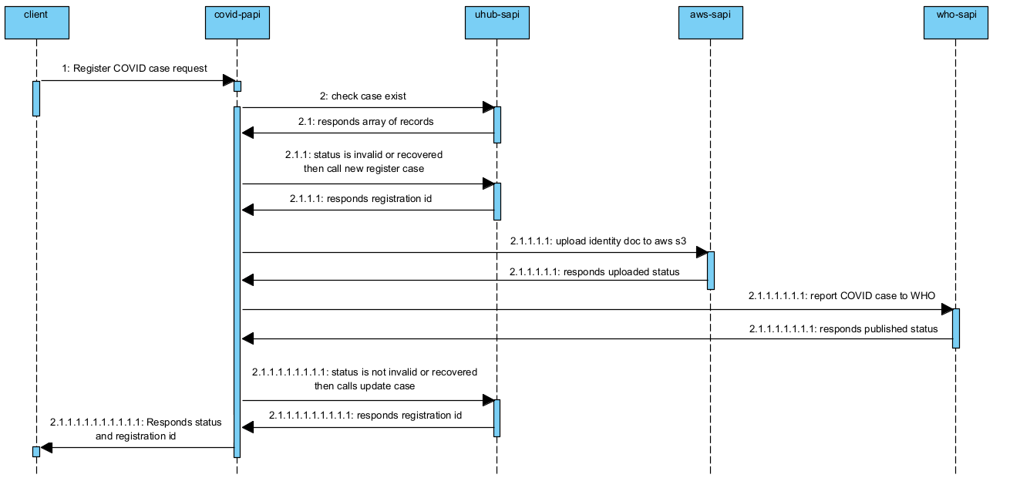

### Input and Output Definitions of API

**Input:** {

   "source":"Hospital1",

   "caseType":"positive",

   "firstName":"John",

   "lastName":"Nixon",

   "phone":"541-754-3010",

   "email":"john@gmail.com",

   "dateOfBirth":"1989-04-26",

   "nationalID":"209-49-6193",

   "nationalIDType":"SSN",

   "address":{

      "streetAddress":"1600 Pennsylvania Avenue NW",

      "city":"Washington",

      "state":"DC",

      "postal":"20500",

      "country":"USA"

   },

"iDoc":"iVBORw0KGgoAAAANSUhEUgAAAOIAAACRCAYAAADepmS4AAAAAXNSR0IArs4c6QAAAARnQU1BAACxjwv8"

}

**Output: 201, Created**

{

       "registrationID": "3673673"

}

### Mapping



### End system details

**uhub-sapi :**

**aws-sapi:**

**who-sapi:**

### Consumers

|  |  |  |
| --- | --- | --- |
| API Consumer | Description | |
| Experience API’s / Client applications | | Experience API’s or client applications consumes covid-papi services to register as case or to fetch COVID cases details. |
| Other UHO applications | | UHO applications can consume uhub-sapi services on requirement since uhub-sapi enabled as utility API in UHO application network. |

### Technical details

|  |  |
| --- | --- |
| API Name | covid-papi |
| Business Requirements | As mentioned in integration solution document |
| API Communication Type | REST |
| Interface Pattern | Request/Reply |
| Interface Definitions | RAML API Specification |
| Sample Request | JSON(Section 3.1.1) |
| Sample Response | JSON(Section 3.1.1) |

### Non Functional

|  |  |
| --- | --- |
| Post Execution Notification Details | Data-Related Failures Handling:  Currently all the errors will be logged into logs with log4j.  Consumer API is responsible to log about error details.  Can be visible in runtime manager.  Technical Errors Handling:  Currently all the errors will be logged into logs with log4j.  Consumer API is responsible to log about error details.  Can be visible in runtime manager. |
| Process Log Audit Details | Audit & Logging:  Created Logs for the following   * Request message at entry point * Request message at system call entry point * Request message at system call entry point * Request completed |

### Error Handling

|  |  |  |
| --- | --- | --- |
| No. | Type of Exception | Exception Handling |
| 1 | Any technical issue | * API shall respond corresponding response message. * API will record the error in logs. * Runtime manager notifications will be configured - TBD * Application Administrative team will be notified using an email notification service- TBD |

### Integration test cases

| **Description** | **Result** |
| --- | --- |
| Successful case registration | 201 - Created |
| System connectivity failure (Database is down) | 503 - The (upstream) service is temporarily not available |
| Invalid JSON payload request | 400 – Bad request |
| Internal server error | 500 – Internal server error |
| API Kit Router errors | Global errors |

### API Endpoint Details

| **Requirement** | **Method** | **Details** |
| --- | --- | --- |
| **Development** | POST | <https://uho-dev-uhub-sapi/covid/v1/>cases |
| **Test** | POST | <https://uho-test-uhub-sapi/covid/v1/>cases |
| **UAT** | POST | <https://uho-uat-uhub-sapi/covid/v1/>cases |
| **Production** | POST | <https://uho-prod-uhub-sapi/covid/v1/>cases |

# API Policies, Access and Network Security - TBD

|  |
| --- |
| Define API policies to be configured / customized |

| **Requirement** | **Details** |
| --- | --- |
| Access to APIs - Authentication | client_id enforcement |
| API Policy | CORS should be enabled |
| Communication over API’s | x-transaction-id |

# Open Issues

|  |  |
| --- | --- |
| **No** | **Open Issues** |
| 1.0 |  |
|  |  |

# Appendix A – Interface details

WSDLs

Exported RAMLs

Tables outlining data design